

Mid Term Examination

Subject Name: Object Oriented Programming
Subject Code: MGMT3501

Submitted by:
Hridaya Shrestha

Student ID: 225IUKLHCMBCS225006

Submitted To:
Lecturer: Girija Prasad Bhattarai

Himalayan College of Management
Kuala Lumpur University of Science and Technology (KLUST)

BCS IT - 6th Semester
Kathmandu, Nepal
Submission Date: 06/15/2026

1. Explain the concepts of classes, objects, methods, and constructors in Java with a suitable example program.
To begin with, a class is a fundamental concept in java and object oriented programming. It acts as a blueprint, template or model for creating objects. It defines the properties and behaviors of an object. A class itself does not occupy memory for its variables until an object is created. For example, to represent students in a school management system, we should create a student class containing attributes such as name, age, and roll number, along with methods to display or update student information.
Secondly, an object is an instance of a class that represents a real world entity. While a class serves as a blueprint, an object is the actual implementation of that blueprint. When an object is created, memory is allocated for its data members which enables us to access variables and methods defined in the class. Each object has its own identity, state, and behavior. We can create multiple objects from the same class and each object can store different data while sharing the same structure and functionality.
Thirdly, a method is a block of code within a class that performs a specific tasks. It defines the behavior of objects and allow them to interact with data. They are used to perform actions such as displaying information, calculating values, updating data and processing user input. A method can accept parameters and also may return a value after completing a task. It helps to avoid code repetition and improve the readability and maintainability of a program. Moreover, methods can be called using objects of a class and they execute only when it is invoked.
Lastly, a constructor is a special type of method which is automatically invoked when an object of a class is created. The main purpose of constructor is to initialize the data members of an object with the appropriate values. However, a constructor has the same name as the class and does not have a return type. Furthermore, java provides two main types of constructors which are default constructors and parameterized constructors. A default constructor initializes objects with default values, whereas a parameterized constructor allows values to be passed during object creation. For example, in a student class, a constructor can be used to assign a student’s name and age when the object is created.

Example Implementation:
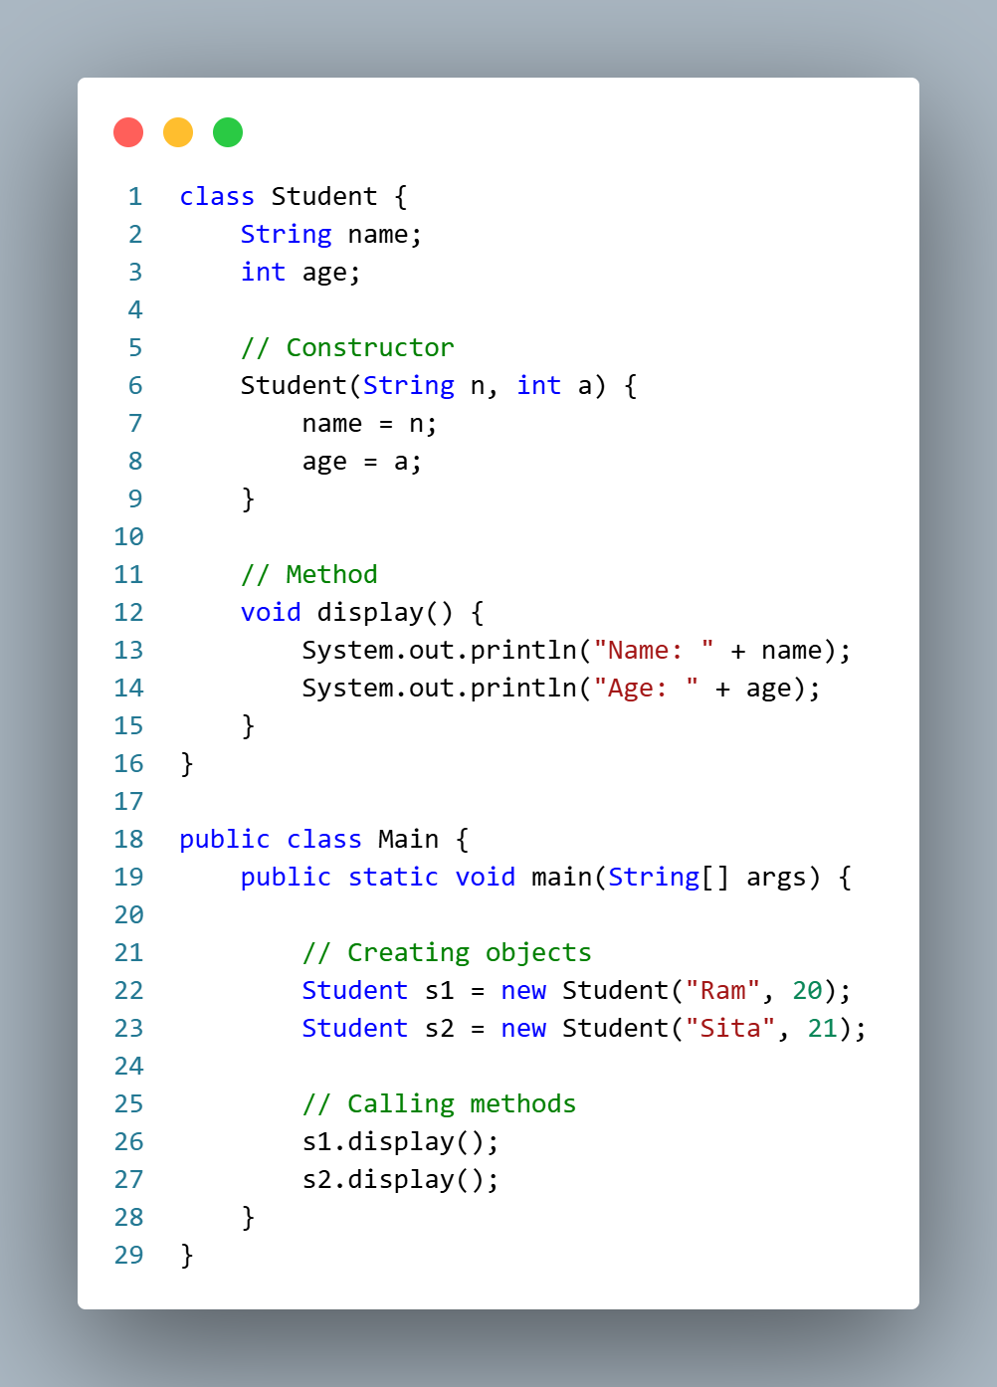
Explanation
- A student is a class that contains two variables, name and age.
- Student (String m, int a) is a constructor that initializes the object’s data.
- display() is a method which is used to display student information.
- s1 and s2 are the objects of the Student class.
- When the objects are created, the constructor is automatically called.
- The display() method is invoked to print the details of each student.

2. Discuss static methods and static fields in Java. How do they differ from instance methods and instance variables? Explain with examples.
In Java, the members of a class can be classified into static members and instance members. Static methods and static fields belong to the class itself, whereas instance methods and instance variables belong to the individual objects of the class.
Firstly, a static method is a method that belongs to the class rather than to an object. It is declared using the static keyword and can be invoked directly using the class name without creating an object. Static methods can access only static variables and other static methods directly because they do not operate on any specific object. They are commonly used for utility functions, mathematical operations and tasks that do not depend on object specific data.
Secondly, a static field is a variable that belongs to the class rather than to individual objects. It is declared using the static keyword. There is only one copy of a static field which is created in the memory when the class is loaded and is shared among all objects of the class. If one object modifies the value of a static field, the change is reflected instantly across all objects. They are commonly used to store information that is common to all objects like company name, counters, configuration values and mathematical constants.
However, the difference between static and instance members are:
Static Methods and Fields | Instance Methods and Variables
They belong to the class. | They belongs to an object.
They are shared among all objects. | Each object has its own copy.
They can be accessed using the class name. | They can be accessed using an object reference.
They are created only once when the class is loaded. | They can be created whenever an object is instantiated.
They do not require object creation. | They requires object creation.
Static methods can directly access only static members. | Instance methods can access both static and instance members.

Example:
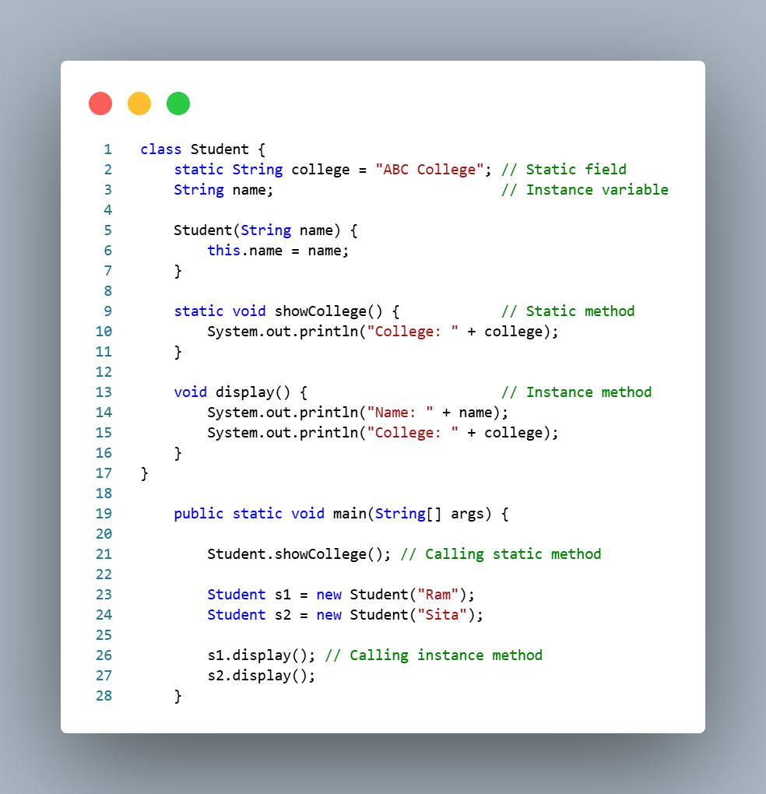
Explanation
A college is a static field shared by all student objects, whereas name is an instance variable that stores different values for each object. The method showCollege() is a static method and can be called using the class name Student, while display() is an instance method and must be called using an object. This demonstrates that static members are common to all objects, whereas instance members are specific to individual objects.

3. What is an Array List in Java? Compare Array List and Array, and explain the advantages of using generic types with suitable examples.
An array list is a part of Java’s Collections Framework and is found in the java.util package. It is a dynamic data structure that can grow or shrink in size automatically when elements are added or removed. Unlike arrays, and Array List does not require a fixed size during declaration. It is commonly used when we need flexible storage of elements.
However, both array list and array are used to store multiple values, but they have several differences. They are as follows:
Array | ArrayList
It is fixed in size and cannot grow or shrink. | It is dynamic in size that can grow or shrink automatically.
It stores both primitive types and objects. | It stores only objects, not primitive types directly.
It is faster performance due to simple structure. | It is slightly slower due to resizing and flexibility.
Syntax is built into Java language. | It is a part of java.util collection framework.
No built in methods for manipulation. | It provides many methods like add(), remove(), get(), etc.

However, the advantages of generics are:
- Strong Compile Time Type Safety: Generics ensure type safety by preventing the addition of incorrect or incompatible data types into a collection.
- Elimination of Manual Typecasting: Since the data type is already specified, there is no need to manually convert objects while retrieving data from the collection.
- Compile Time Error Checking: Errors related to incorrect data types are detected during compilation rather than at runtime, making programs more reliable.
- Code Reusability: Generics allow the same class, method or data structure to work with different data types, improving flexibility and reusability of code.

Example:
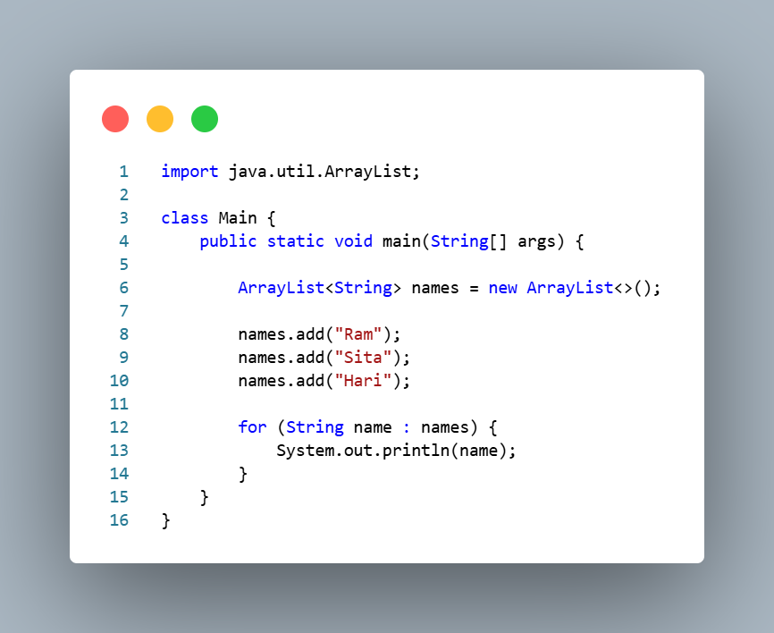
Overall, an ArrayList is a dynamic and flexible version of an array provided by Java’s Collection Framework. It offers more flexibility and useful built in methods. The use of generics improves type safety, reduces errors and makes the code cleaner and more efficient as compared to arrays.

4. Explain the concepts of inheritance and polymorphism in Java. Differentiate between method overloading and method overriding with examples.
Inheritance is the key feature of OOP which allows us to create a new class from an existing class. The new class that is created is known as subclass and the existing class from where the child class is known as superclass, also called parent.
The main purpose of inheritance in java is to provide the reusability of code, so that a class needs to define only its unique features while inheriting common properties and functionalities from another class. Inheritance also helps establish a hierarchical relationship between classes, making programs more organized and easier to maintain.
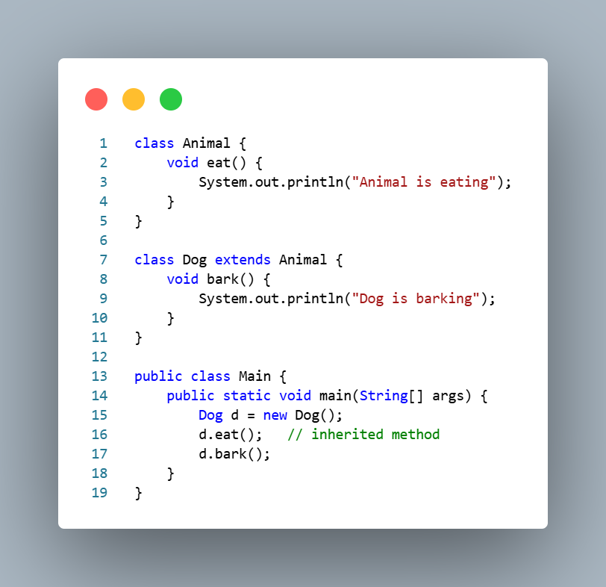
Polymorphism means many forms. It is the ability of an object or method to take different forms depending on the situation. It also allows the same method name to perform different tasks, improving flexibility, maintainability, and code reusability. Polymorphism enables us to write more generic and reusable code by allowing objects of different classes to be treated in a similar way. In Java, polymorphism is mainly of two types. They are:
- Compile Time Polymorphism
- Run Time Polymorphism
However, the difference between method overloading and method overriding are:
Method Overloading | Method Overriding
It occurs within the same class. | It occurs between superclass and subclass.
Methods have the same name but different parameters. | Methods have the same name and same parameters.
Compile time polymorphism. | Run time polymorphism.
Inheritance is not required. | Inheritance is required.
It improves readability and flexibility. | It allows modification of inherited behavior.
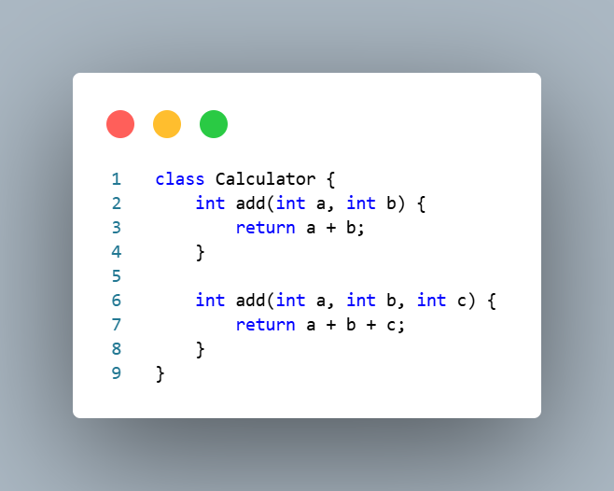 | 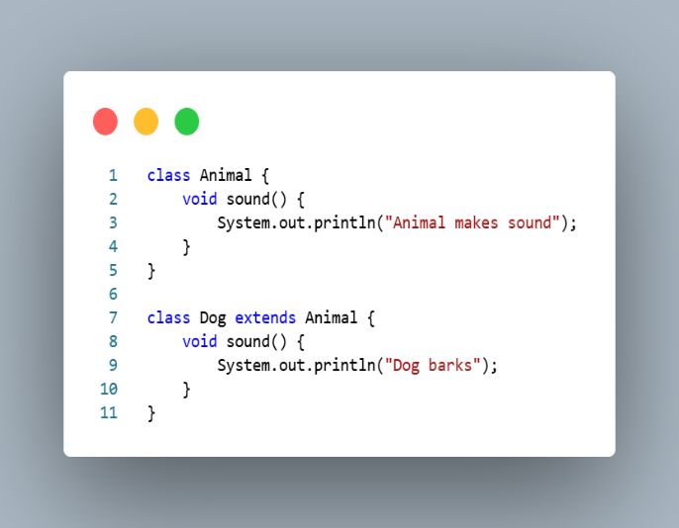

In conclusion, inheritance enables a class to acquire the properties and methods of another class, promoting code reusability and reducing redundancy. Polymorphism allows methods to exhibit different behaviors in different situations which makes program more flexible. Method overloading achieves compile time polymorphism through multiple methods with the same name but different parameters, whereas method overriding achieves run time polymorphism by redefining an inherited method in a subclass.

5. What are abstract classes and interfaces in Java? Compare them and explain their significance in object-oriented programming with examples.
An abstract class is a type of class which cannot be instantiated, which means objects cannot be created directly from it. It is declared using the abstract keyword. However, an abstract class can contain both abstract methods and concrete methods. It is mainly used when different subclasses share some common properties and behaviors but also need their own specific implementations.
Moreover, it provides a partial implementation of a program and act as a base class for other classes. Any class that extends an abstract class must implement all of its abstract methods.
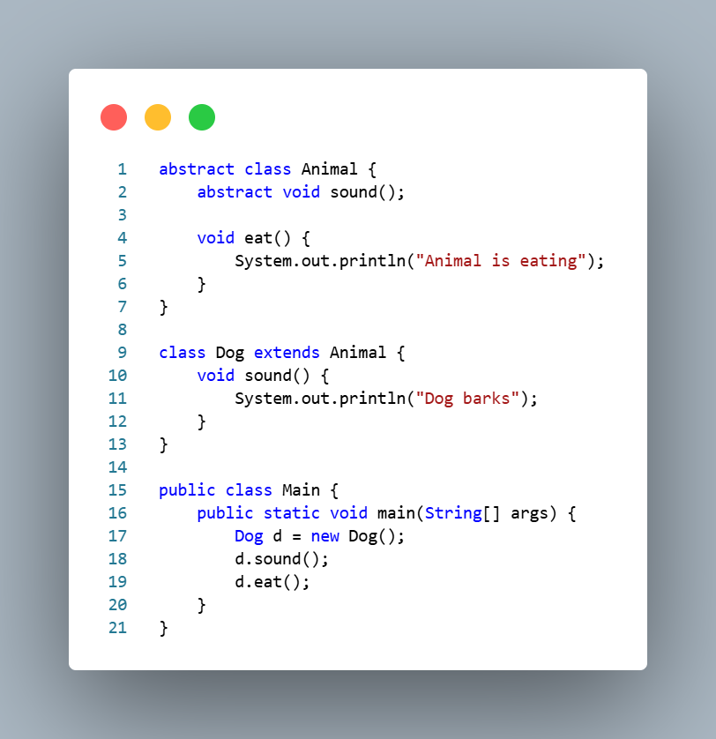
Secondly, an interface is a blueprint of a class that contains method declarations and constants. It is declared using the interface keyword. An interface specifies what a class should do but now how it should do it. A class implements an interface using the implements keyword.
Interfaces are used to achieve complete abstraction and support multiple inheritance in Java, as a class can implement more than one interface.

The comparison between abstract classes and interfaces are:
Abstract Class | Interface
It is declared using the abstract keyword. | Declared using the interface keyword.
It can contain both abstract and concrete methods. | Mainly contains abstract methods.
It can have instance variables. | Variable are public, static and final by default.
It supports single inheritance only. | It supports multiple inheritance though implementation.
A class extends an abstract class. | A class implements an interface.
It is used when classes share common behavior and state. | It is used when unrelated classes need to follow the same contact.

The significance of abstract classes and interfaces in Object Oriented Programming
The abstract classes and interfaces are important concepts in Object Oriented Programming because they help achieve abstraction which means hiding implementation details and showing only essential features. They make programs more flexible, reusable and easier to maintain.
Abstract classes are useful when several related classes share common code, while interfaces are useful when different classes need to provide the same functionality in different ways. They also support polymorphism, allowing objects of different classes to be treated through a common type.

Overall, an abstract class is partially implemented class that can contain both abstract and concrete methods, whereas an interface defines a contract that implementing classes must follow. Both are used to achieve abstraction and improve code reusability. Abstract classes are suitable when classes share common features, while interfaces are suitable for defining common behavior across different classes. These concepts play a vital role in developing flexible and maintainable java applications.s

6. Describe Java exception handling mechanisms. Explain try, catch, finally, throw, and throws keywords with suitable examples.
Exception handling in java is a way to deal with runtime errors so that the normal flow of the program is not interrupted. An exception is an unwanted event that occurs during program execution, such as dividing by zero, accessing an invalid array index, or opening a file that does not exist. However, java provides five important keywords for exception handling. They are:
- Try Block
The try block contains code which may cause an exception. It must be followed by a catch block or a finally block. For example,
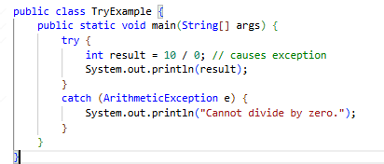
Output: cannot divide by zero.

- Catch Block
The catch block handles the exception thrown by the try block. It prevents the program from terminating abnormally. For example,
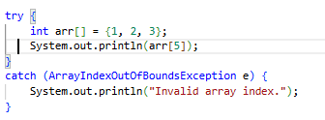
Output: Invalid array index.

- Finally Block
The finally block is always executed whether an exception occurs or not. It is generally used for cleanup tasks such as closing files or database connections. For example,
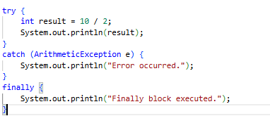
Output:
5
Finally block executed

- Throw Keyword
The throw keyword is used to explicitly create and throw an exception. For example,
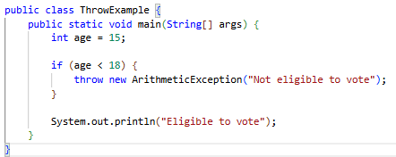
Output:
Exception in thread “main” java.lang.ArithmeticException:
Not eligible to vote

- Throws Keyword
The throws keyword is used in a method declaration to indicate that the method may throw an exception. It passes the responsibility of handling the exception to the caller. For example,
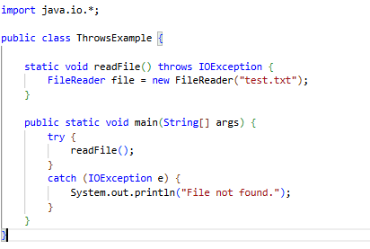
Output: File not found, if file does not exist.

Overall, java exception handling helps to manage runtime errors and prevents abnormal program termination. The try block contains risky code, catch handles exceptions, finally executes important cleanup code, throw explicitly generates an exception and throws declares possible exceptions in a method. Together, these mechanism make Java programs more reliable and robust.

7. What are custom exceptions in Java? Explain how to create and use a user-defined exception with an example program.

